**JOIN, RIGHT JOIN & LEFT JOIN**

1. SELECT id_penjualan, total_harga, nama_obat, harga_jual FROM detail_penjualan JOIN obat ON detail_penjualan.id_obat = obat.id ORDER BY id_penjualan ASC

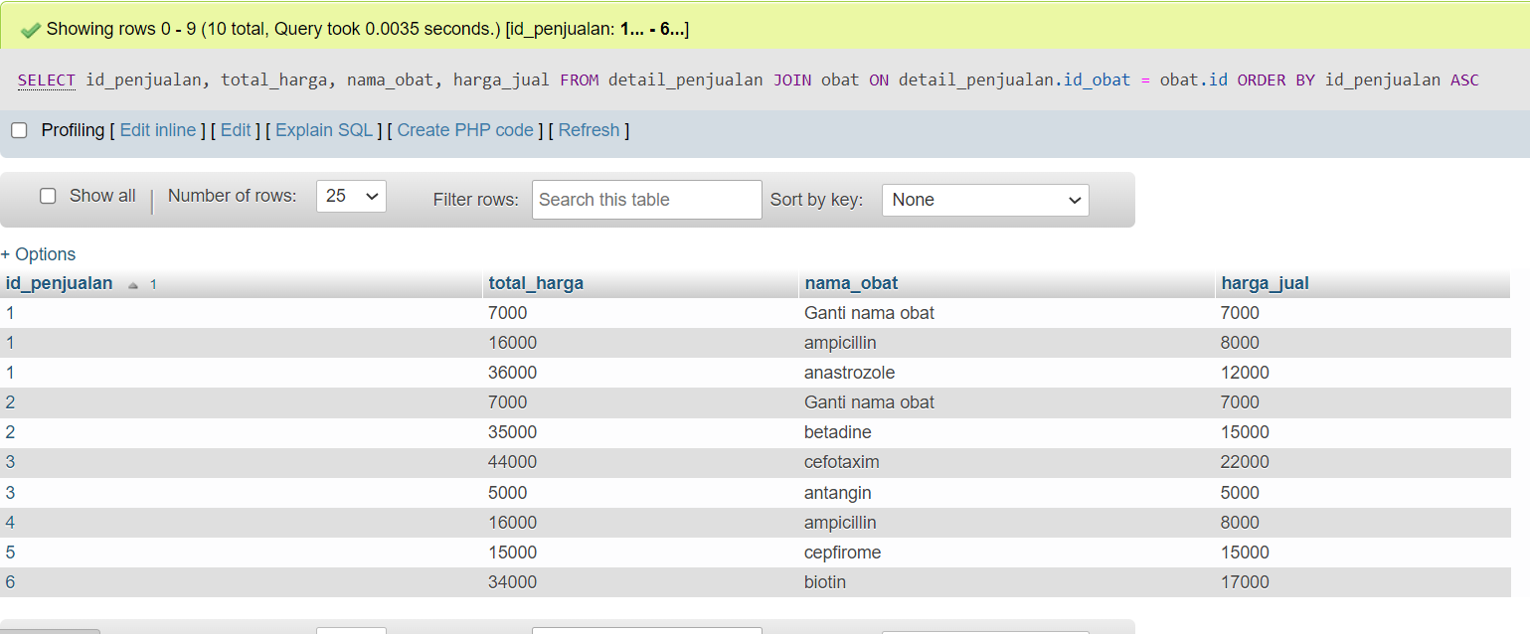

1. SELECT id_penjualan, total_harga, nama_obat, harga_jual FROM detail_penjualan RIGHT JOIN obat ON detail_penjualan.id_obat = obat.id ORDER BY id_penjualan ASC

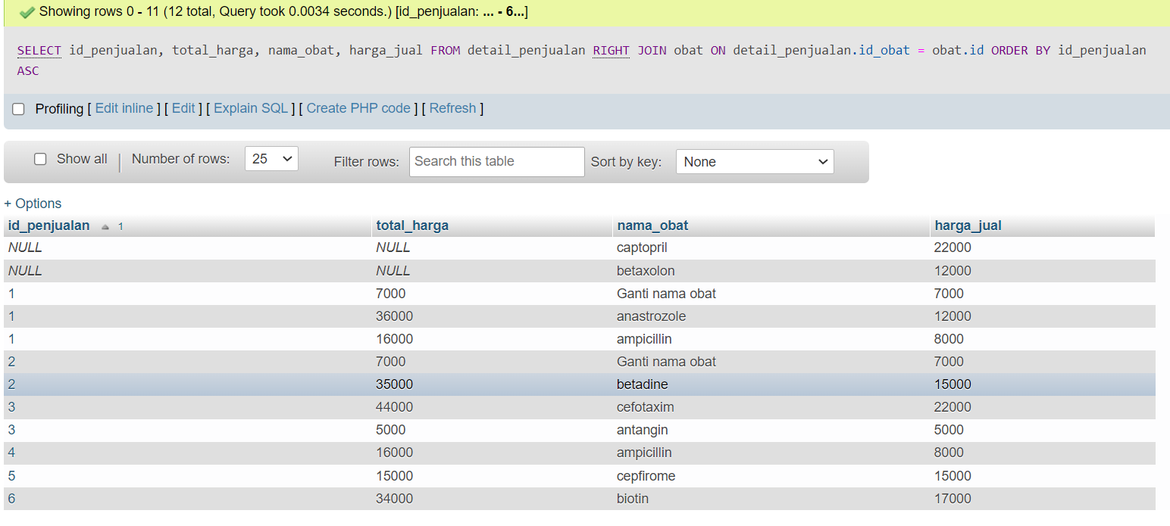

1. SELECT id_penjualan, total_harga, nama_obat, harga_jual FROM detail_penjualan LEFT JOIN obat ON detail_penjualan.id_obat = obat.id ORDER BY id_penjualan ASC

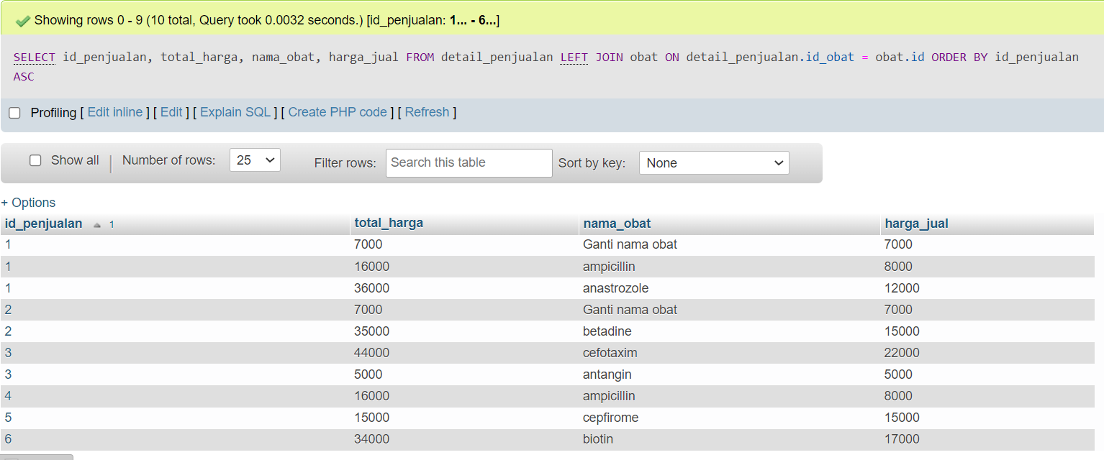

1. SELECT id_penjualan, jumlah, total_harga, nama_obat, harga_jual FROM detail_penjualan JOIN obat ON detail_penjualan.id_obat = obat.id WHERE id_obat = 1 ORDER BY id_penjualan ASC

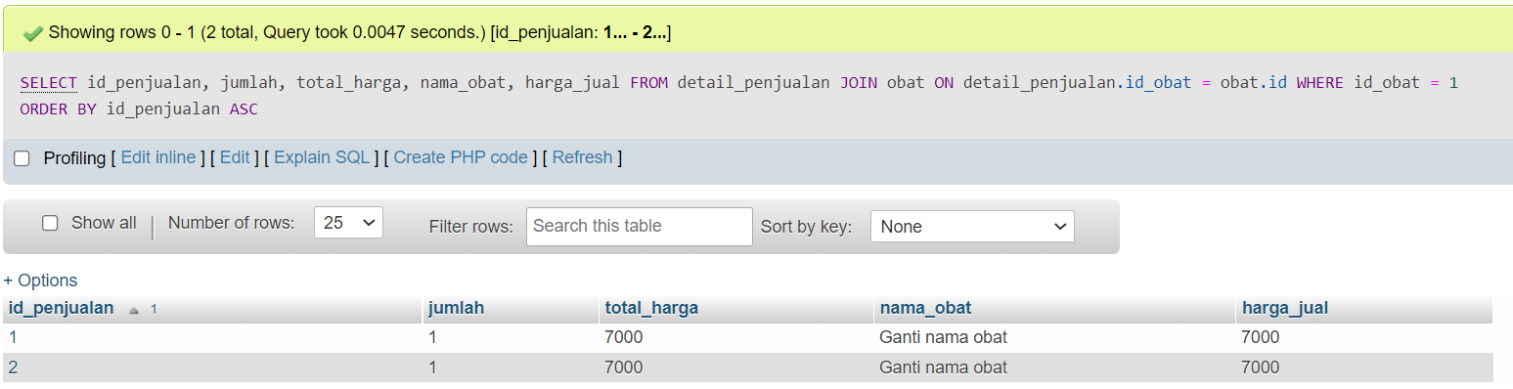

1. SELECT id_penjualan, jumlah, total_harga, nama_obat, harga_jual FROM detail_penjualan JOIN obat ON detail_penjualan.id_obat = obat.id WHERE total_harga >= 10000 ORDER BY id_penjualan DESC

